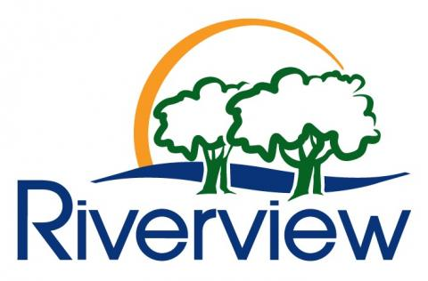
The Town of Riverview
Call to Artists
2019

The Town of Riverview invites artists to take part in their Art Procurement Program. The Art Procurement Jury will select artwork(s) to purchase on behalf of the Town of Riverview to be added to the town’s art collection.
ELIGIBILITY
Artists must have been a resident of Riverview for at least twelve (12) consecutive months. Artist eligibility will not be reliant on an artist’s professional status but rather on the artwork. No work by any member of the Jury or their immediate family will be considered for purchase.
ART ACQUISITION
The Town of Riverview will purchase artwork(s) from the works submitted for this call. The artwork must be deemed appropriate for the town’s art collection based on the selection criteria established by the Art Procurement Program Policy. The artwork will be displayed in Council Chambers for up to two years following acquisition and then may be relocated to another town owned building.
SUBMISSIONS
Each artist may submit up to three (3) pieces of artwork. Artwork must be original and be suitably framed and ready for hanging. The attached form must be filled out completely and affixed to the back of the artwork submitted. Submissions of images of work will only be permitted for sculptural pieces. Art that is not accompanied by this form will not be considered.
ARTWORK DROP-OFF
Artwork must be delivered to the Town of Riverview Parks and Recreation Department, 55 Biggs Drive on Wednesday, September 11, 2019 between 9a.m. - 5pm. Submissions will not be accepted after this date and time. The artist is responsible for unpacking their artwork and taking their packaging with them. Subsequently, the artist is responsible for re-wrapping upon pick-up.
ACCEPTANCE
Only artists whose artwork is selected for purchase will be notified by telephone the afternoon of the following day, Thursday, September 12, 2019.
ARTWORK PICK-UP
Artwork not chosen must be picked up on the afternoon of Thursday, September 12, 2019 at the above drop-off location between 1:00 - 5:00pm or the morning of Friday, September 13 between 9 a.m. and noon. The Town of Riverview is not responsible for any artwork not picked up at this time.

The Town of Riverview
Call to Artists
2019

Form must be affixed to the back of the artwork
1 to a maximum of 3 submissions per artist
Name of Artist _________________________________________________________________________________

Address ______________________________________________________________________________________

Telephone Number(s) ___________________________________________________________________________

Email ________________________________________________________________________________

Title of work: __________________________________________________________________________

Date of completion:_____________________________________________________________________

Medium: _____________________________________________________________________________

Size: Width _____________ Height _____________ Depth _____________ _____ cm
_____ inches
Price: $_________________

Drop-off is Wednesday, September 11, 2019 from 9a.m. - 5pm at the Riverview Parks and Recreation building 55 Biggs Drive, Riverview NB, E1B 3Y8
Questions? Contact the Art Procurement Committee via Paulette Tingley 387-2024 or PTingley@townofriverview.ca

